Talk Homework
At St. Clare’s we recognise the importance of speaking and listening skills therefore we set talking homework for you and your family to complete with your child. Please discuss these talking points and complete the activities with your child. You don’t need to return this homework to school.
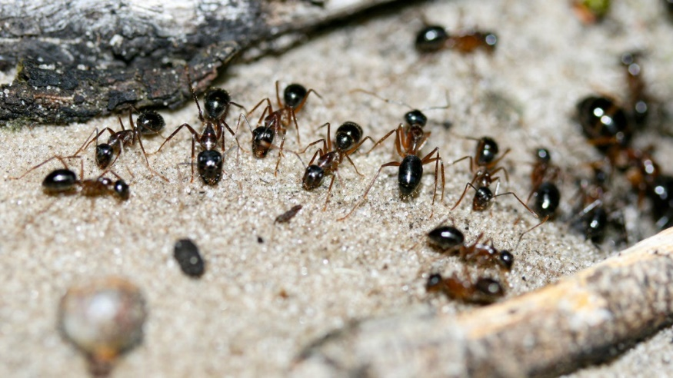
How many different minibeasts can you name?

Do you know where some of these minibeasts live or what they eat?

Many minibeasts have different jobs to do. What do bees, ants and butterflies do?

How do minibeasts help us to survive?

Is there anything we can do to help minibeasts?

How should we treat minibeasts and why is that important?

