Talk Homework
At St. Clare’s we recognise the importance of speaking and listening skills therefore we set talking homework for you and your family to complete with your child. Please discuss these talking points and complete the activities with your child. You don’t need to return this homework to school.

What do you know about the continent of Africa?

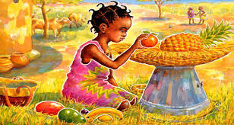
Where do people live? What kind of housing do they have, is it all the same? Do people live in cities, towns and villages?

What food is available in the continent of Africa? Where do we get our food from?

Have you tasted any food that has come from a different country? Have you tasted any exotic fruits?

What animals can be found in the continent of Africa? What animals can be found in the U.K?

Do you know what different wild animals eat? Are they carnivores, herbivores omnivores?

